**Week 3 task**

**Creating lambda function to Build a pipeline for data ingestion, model inference, and alert generation**

**We will first use the endpoint that we created in the last task so that lambda function can trigger it later in our pipeline**

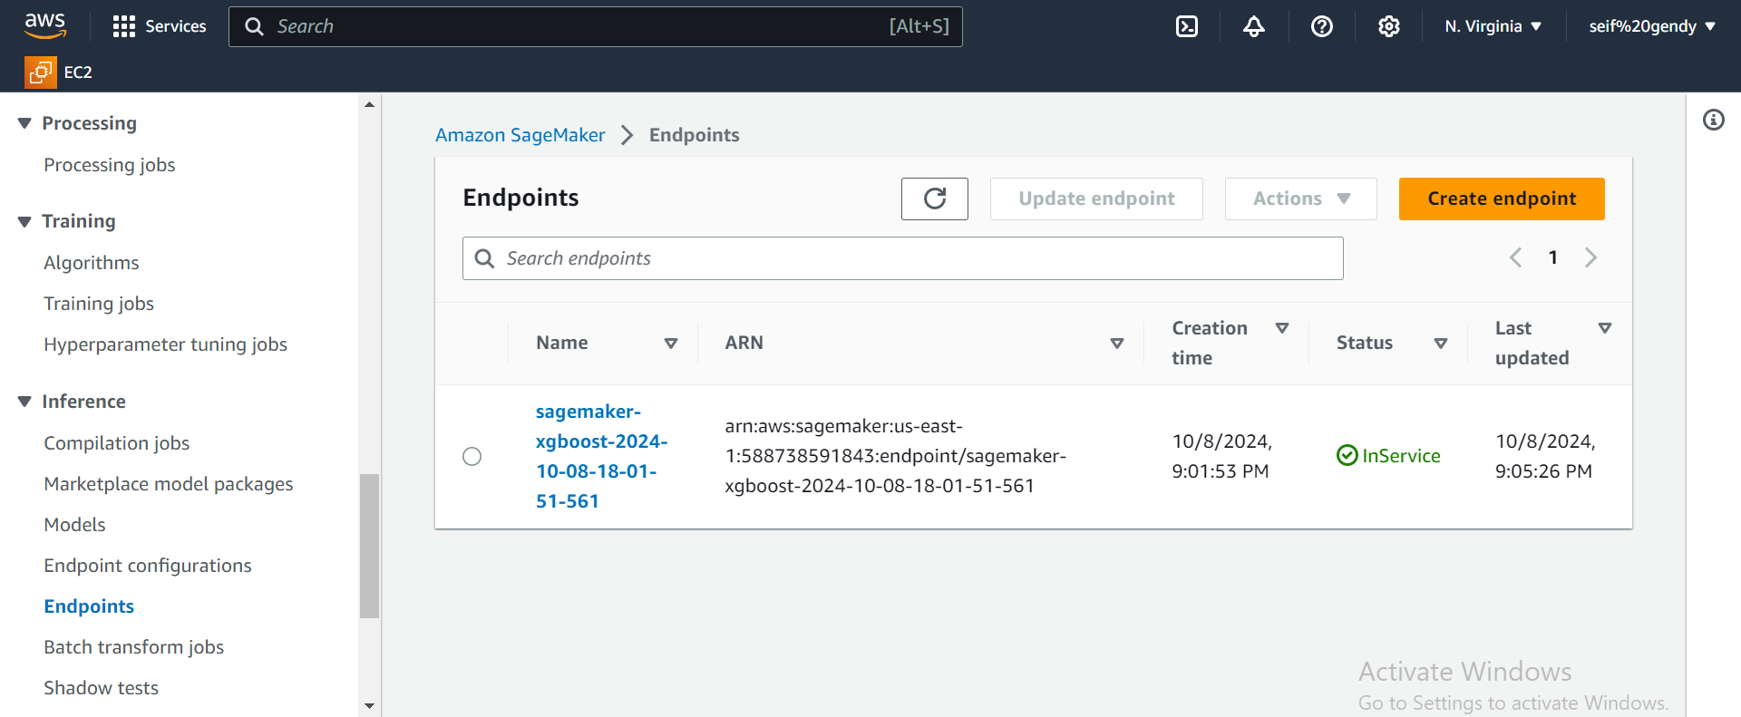

**Then we create a lambda function**

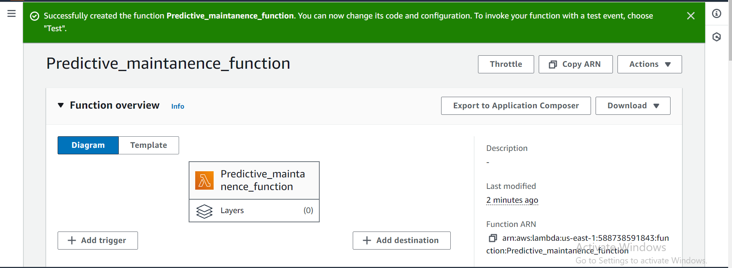

**Writing lambda function code**

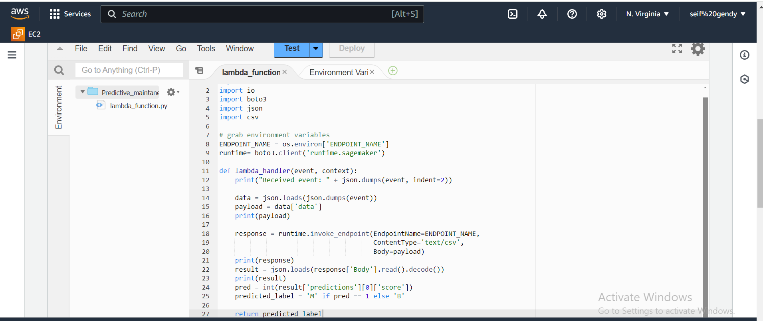

**Add an environment variable with the value of our endpoint**

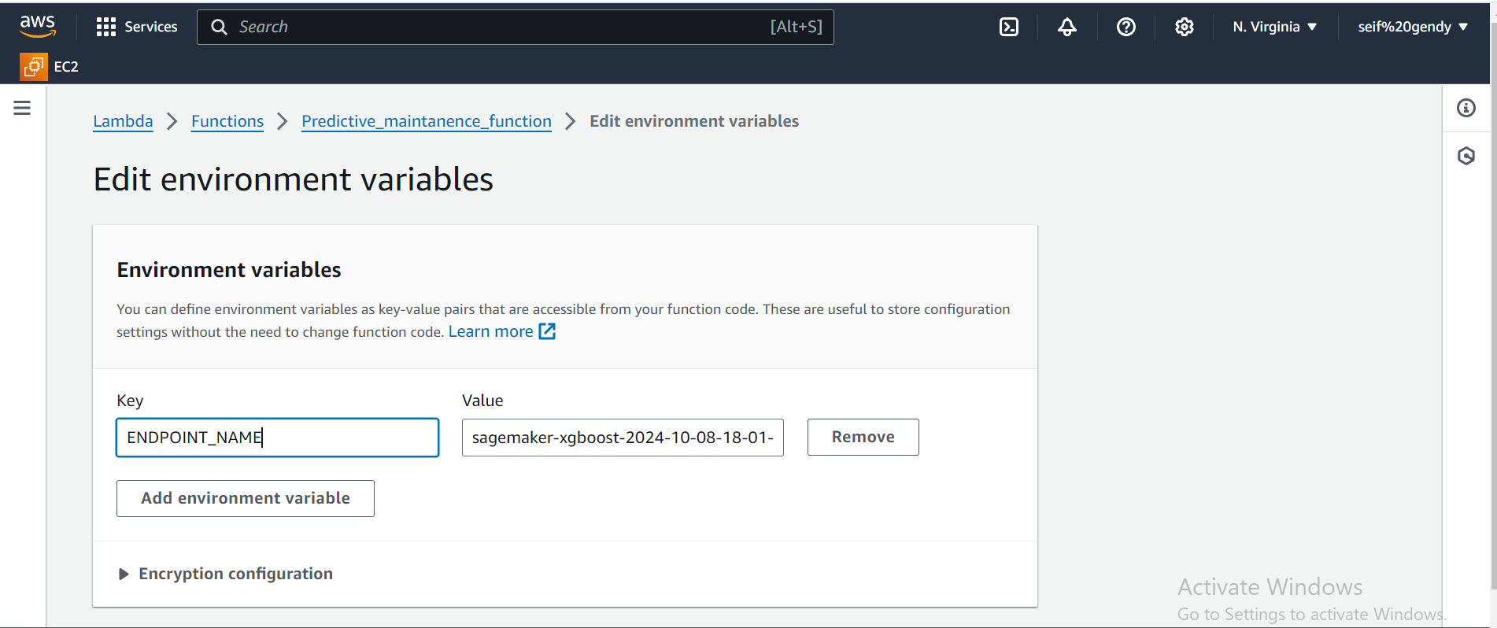

**Check for the IAM role of the Lmabda function**

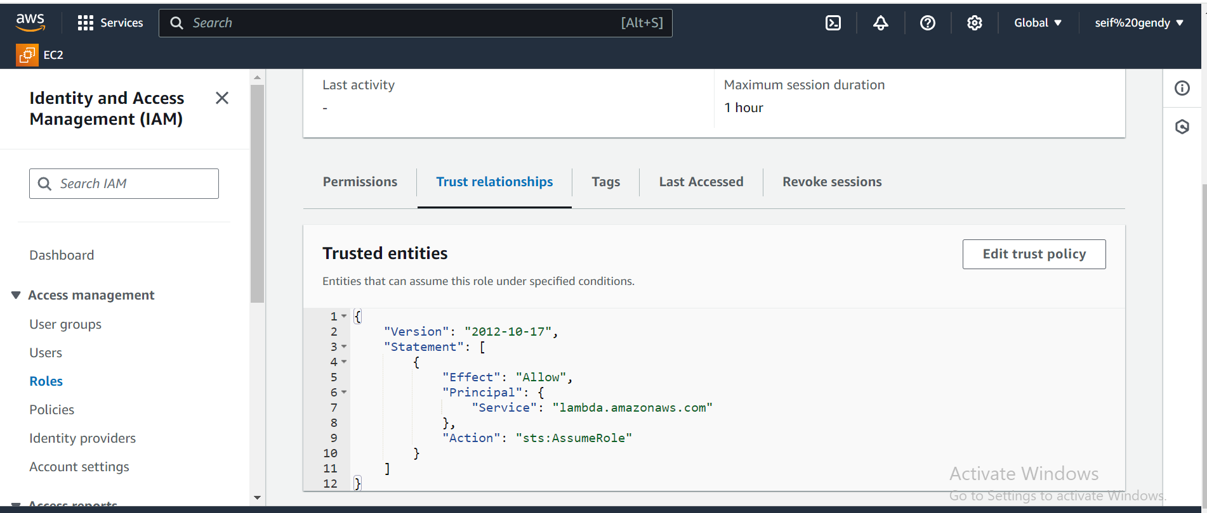

**Then we edit the IAM role policy of the lambda function to be able to invoke the endpoint**

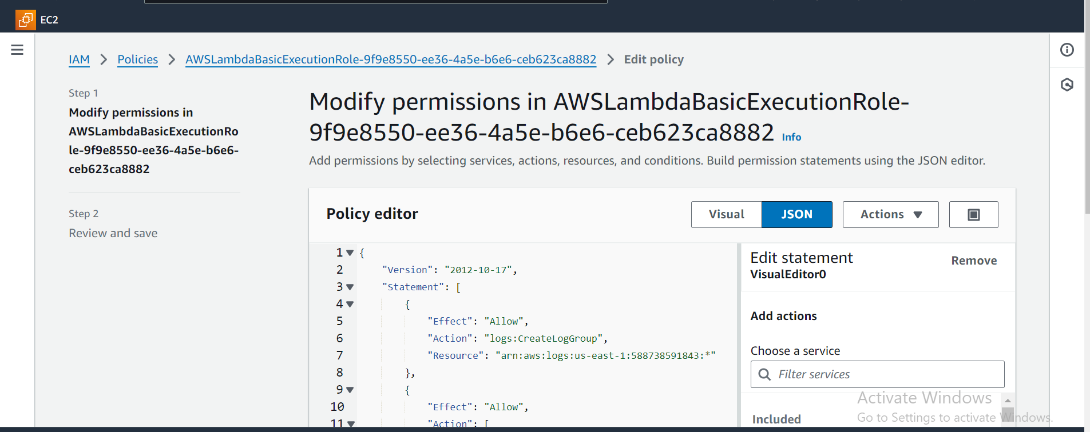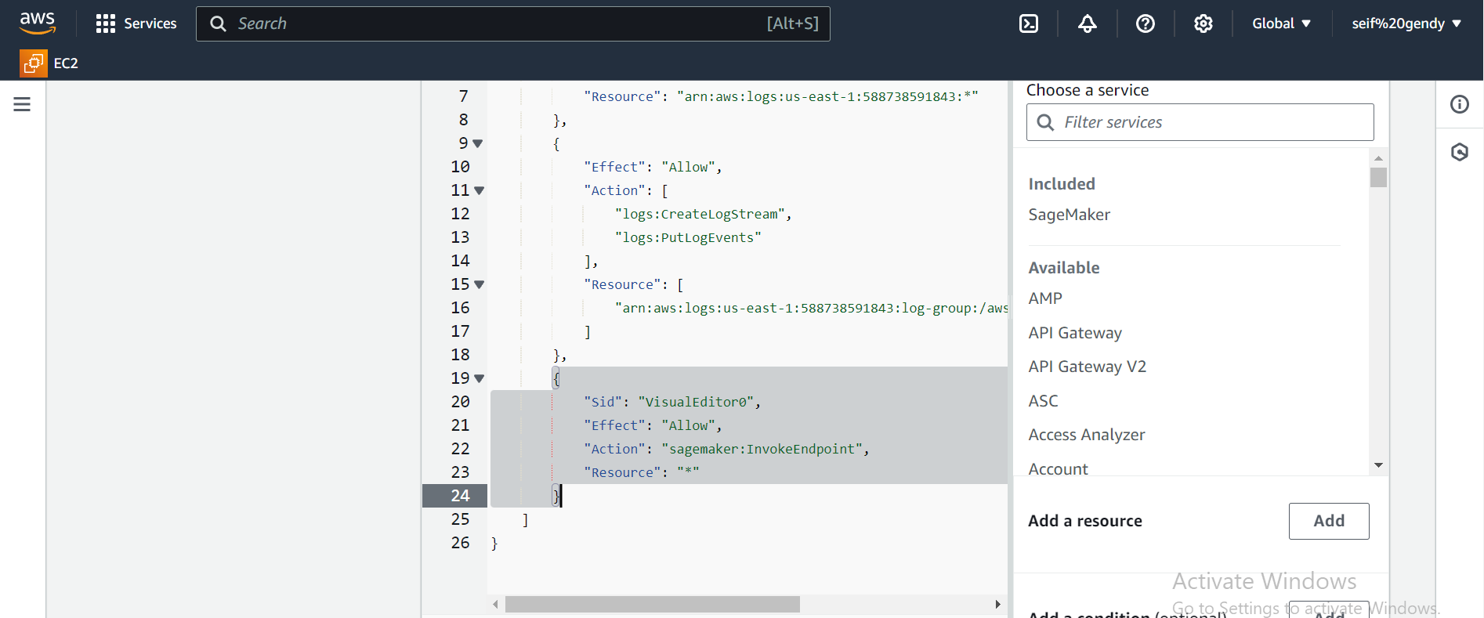

**Now lets create our API**

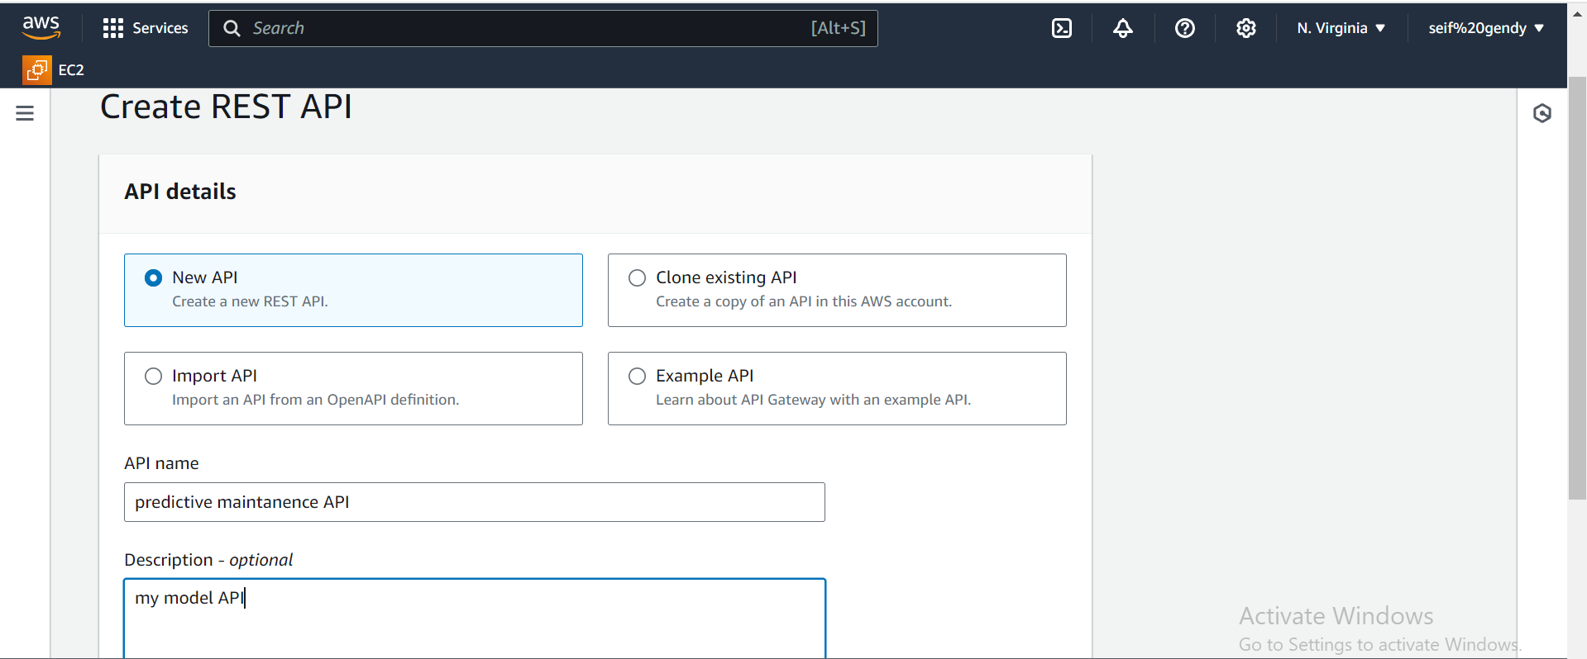

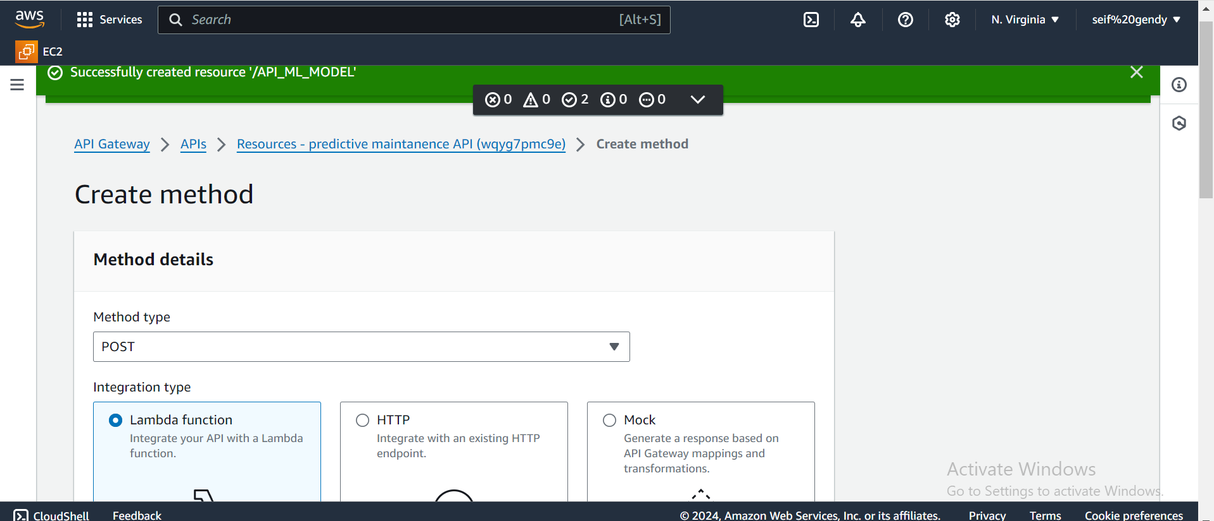

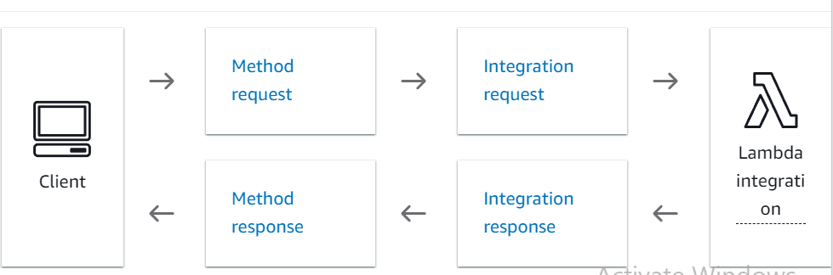

**Then deploy our API**

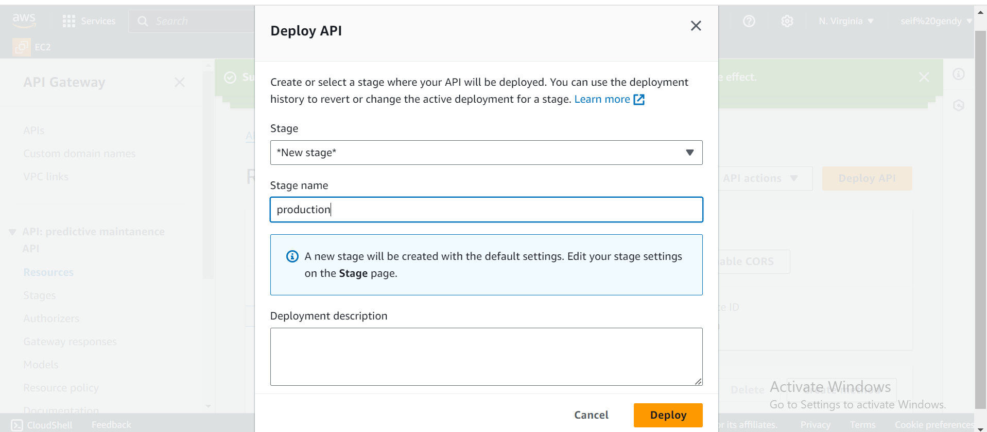

**Now we have our invoke URL**

